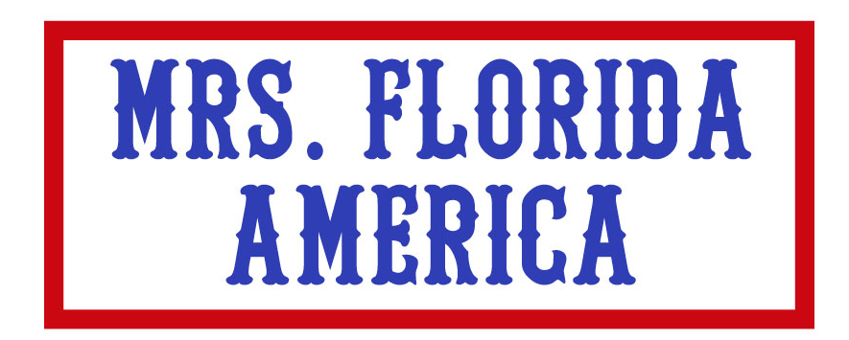

Sponsorship Opportunities Commitment Form

SPONSORSHIP OPPORTUNITY:

Name/Title:
Company: Email:
Address:
Phone: Fax:

IN-KIND PRODUCT DONATION INFORMATION:

Estimated Value of Contribution: $

Description of Contribution (including limitations, valid dates and restrictions): ___________________________________________________________________________________________________________________________________________________________________________________________________________________________

If goods or materials, will you deliver? If yes, when?

If a gift certificate: ___ Attached ___ To be mailed on ____/____/____

Please mail or fax completed form to:
Mrs. Florida-America Pageant
c/o HR Dept – Westgate Resorts
2801 Old Winter Garden Road
Ocoee, FL 34761

E-mail: MrsFL_America@wgresorts.com Website: MRSFLAMERICA.COM
Office: 407-321-246-7443 Fax: 407-355-2932

Payment Method: Check MasterCard Visa AmEx

Card # Exp. Date CDI #

Signature: Zip Code of Credit Card

Thank you! We look forward to sharing this special day together!
Westgate Resort foundation is a registered not-for-profit 501(c)(3) organization. However, please consult your accountant or tax advisor for information on the potential value of a tax deduction.

